## HW7_Clustering_201511646 나여영

1. In this example, we have distances between ten American cities based on the flying mileages between them. The objective is to see if we can define clusters of these cities based on the distances.

Atlanta<-c(0,587,1212,701,1936,604,748,2139,2182,543)  
Chicago<-c(587,0,920,940,1745,1188,713,1858,1737,597)  
Denver<-c(1212,920,0,879,831,1726,1631,949,1021,1494)  
Houston<-c(701,940,879,0,1374,968,1420,1645,1891,1220)  
LA<-c(1936,1745,831,1374,0,2339,2451,347,959,2300)  
Miami<-c(604,1188,1726,968,2339,0,1092,2594,2734,923)  
Newyork<-c(748,713,1631,1420,2451,1092,0,2571,2408,205)  
Sanfrancisco<-c(2139,1858,949,1645,347,2594,2571,0,678,2442)  
Seattle<-c(2182,1737,1021,1891,959,2734,2408,678,0,2329)  
WashingtonDC<-c(543,597,1494,1220,2300,923,205,2442,2329,0)

다음은 대칭행렬이 맞는지 확인하는 과정이다

cities<-matrix(c(Atlanta,Chicago,Denver, Houston,LA, Miami, Newyork,Sanfrancisco, Seattle, WashingtonDC),10,byrow=T)  
cities

## [,1] [,2] [,3] [,4] [,5] [,6] [,7] [,8] [,9] [,10]  
## [1,] 0 587 1212 701 1936 604 748 2139 2182 543  
## [2,] 587 0 920 940 1745 1188 713 1858 1737 597  
## [3,] 1212 920 0 879 831 1726 1631 949 1021 1494  
## [4,] 701 940 879 0 1374 968 1420 1645 1891 1220  
## [5,] 1936 1745 831 1374 0 2339 2451 347 959 2300  
## [6,] 604 1188 1726 968 2339 0 1092 2594 2734 923  
## [7,] 748 713 1631 1420 2451 1092 0 2571 2408 205  
## [8,] 2139 1858 949 1645 347 2594 2571 0 678 2442  
## [9,] 2182 1737 1021 1891 959 2734 2408 678 0 2329  
## [10,] 543 597 1494 1220 2300 923 205 2442 2329 0

library(dplyr)

## Warning: package 'dplyr' was built under R version 3.4.2

##   
## Attaching package: 'dplyr'

Tcities=t(cities)

all_equal(cities, Tcities)

## [1] TRUE

맞는지 확인했으므로 그 후 scatter plot을 확인해 데이터의 분포를 본다.

colnames(cities)<-c("Atlanta","Chicago","Denver", "Houston","LA", "Miami", "Newyork","Sanfrancisco", "Seattle", "WashingtonDC")  
rownames(cities)<-c("Atlanta","Chicago","Denver", "Houston","LA", "Miami", "Newyork","Sanfrancisco", "Seattle", "WashingtonDC")  
  
plot(cities,pch = 19, xlab = c("x coordinate"), ylab = c("y coordinate"),main = "Scatter plot of Cities")  
text(cities, labels = abbreviate(colnames(cities)), cex = 0.8, pos = 3, col = "blue") # pos=1 : at the bottom

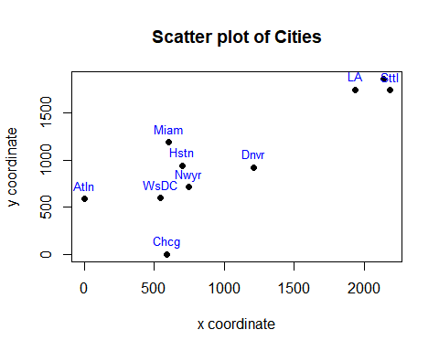

1. Do the cluster analysis using (1) single linkage, (2) average linkage and (3) the centroid method.

(1)single linkage

hc1_cities<-hclust(dist(cities, method="euclidian")^2, method="single")  
hc1_cities

## Call:  
## hclust(d = dist(cities, method = "euclidian")^2, method = "single")  
##   
## Cluster method : single   
## Distance : euclidean   
## Number of objects: 10

rev(hc1_cities) #height : 군집간 거리 / merge: 병합순

## $dist.method  
## [1] "euclidean"  
##   
## $call  
## hclust(d = dist(cities, method = "euclidian")^2, method = "single")  
##   
## $method  
## [1] "single"  
##   
## $labels  
## [1] "Atlanta" "Chicago" "Denver" "Houston"   
## [5] "LA" "Miami" "Newyork" "Sanfrancisco"  
## [9] "Seattle" "WashingtonDC"  
##   
## $order  
## [1] 9 5 8 3 4 6 7 10 1 2  
##   
## $height  
## [1] 272544 560711 1435040 1490187 1581207 2363192 2905270 4037129 4895001  
##   
## $merge  
## [,1] [,2]  
## [1,] -7 -10  
## [2,] -5 -8  
## [3,] -9 2  
## [4,] -1 -2  
## [5,] 1 4  
## [6,] -6 5  
## [7,] -4 6  
## [8,] -3 7  
## [9,] 3 8

1. average linkage

hc2_cities<-hclust(dist(cities, method="euclidian")^2, method="average")  
hc2_cities

## Call:  
## hclust(d = dist(cities, method = "euclidian")^2, method = "average")  
##   
## Cluster method : average   
## Distance : euclidean   
## Number of objects: 10

rev(hc2_cities)

## $dist.method  
## [1] "euclidean"  
##   
## $call  
## hclust(d = dist(cities, method = "euclidian")^2, method = "average")  
##   
## $method  
## [1] "average"  
##   
## $labels  
## [1] "Atlanta" "Chicago" "Denver" "Houston"   
## [5] "LA" "Miami" "Newyork" "Sanfrancisco"  
## [9] "Seattle" "WashingtonDC"  
##   
## $order  
## [1] 9 5 8 6 7 10 1 2 3 4  
##   
## $height  
## [1] 272544 560711 1490187 1953324 2528224 3651036 4037129 8604104  
## [9] 21933100  
##   
## $merge  
## [,1] [,2]  
## [1,] -7 -10  
## [2,] -5 -8  
## [3,] -1 -2  
## [4,] -9 2  
## [5,] 1 3  
## [6,] -6 5  
## [7,] -3 -4  
## [8,] 6 7  
## [9,] 4 8

1. centroid method

hc3_cities<-hclust(dist(cities, method="euclidian")^2, method="centroid")  
hc3_cities

## Call:  
## hclust(d = dist(cities, method = "euclidian")^2, method = "centroid")  
##   
## Cluster method : centroid   
## Distance : euclidean   
## Number of objects: 10

rev(hc3_cities)

## $dist.method  
## [1] "euclidean"  
##   
## $call  
## hclust(d = dist(cities, method = "euclidian")^2, method = "centroid")  
##   
## $method  
## [1] "centroid"  
##   
## $labels  
## [1] "Atlanta" "Chicago" "Denver" "Houston"   
## [5] "LA" "Miami" "Newyork" "Sanfrancisco"  
## [9] "Seattle" "WashingtonDC"  
##   
## $order  
## [1] 9 5 8 6 7 10 1 2 3 4  
##   
## $height  
## [1] 272544 560711 1490187 1813146 2087541 2908810 4037129 6535631  
## [9] 19057993  
##   
## $merge  
## [,1] [,2]  
## [1,] -7 -10  
## [2,] -5 -8  
## [3,] -1 -2  
## [4,] -9 2  
## [5,] 1 3  
## [6,] -6 5  
## [7,] -3 -4  
## [8,] 6 7  
## [9,] 4 8

1. For each method, (a) determine the number of clusters suggested by dendrogram, the CCC method and the Hotelling T-squared method. Show the assignment of cities to the clusters.
2. dendrogram

my_par = par(no.readonly = TRUE)  
par(oma = c(0, 0, 1, 0))  
par(mfrow=c(1,3))  
plot(hc1_cities, hang = -1, main="Single linkage") # hang = -1 : line from the bottom  
plot(hc2_cities, hang=-1, main="Average linkage")  
plot(hc3_cities, hang=-1, main="Centroid linkage")

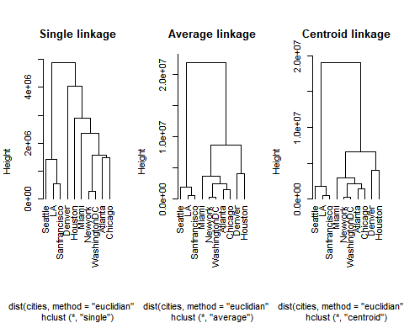

결론 : 군집 개수를 두개로 했을 때 Seattle, LA, Sanfrancisco 를 한그룹 / 나머지를 한 그룹 이렇게 분류할 수 있다. 하지만 3개 이상부터는 방법에 따라 다르게 묶이게 된다.